**EXAMPLE**

**AstroEngr 201**

**Project Submittal Sheet**

**PROJECT RV to COEs**

* **Project Complete Cadet Name _____________________**

Once you complete this project, you must submit hard copies of your work to your instructor for review and assessment. All of the following are required in order to receive credit for completion. Your instructor will check off your completed sections and provide written comments in the space below or on the pages you submit as appropriate. Please attach this cover sheet.

* **Algorithms (1 for the main script file and 1 for each sub-function. Could someone duplicate your program from this?)**
* **Clear, Concise and Documented m-file Code**
* **Correct Answers for Provided Test Cases in RV1.dat. (Create a table of expected vs actual values and attach copies of the output files and “hand calculations”.)**
* **Additional Sufficient Test Cases and Comparison Table (State why you had to add extra test cases, or why you didn’t)**

**Be sure to include the Assignment coverpage, as is done above.**

**This format applies to all assignments. Not all of them will have this many parts.**

**Algorithms**

Include algorithms for your main program and sub-functions if applicable.

Code

Paste code here using the same format as Matlab (Paste as “Keep Source Formatting”)

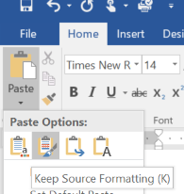



Or for keyboard shortcut: press Ctrl+v then Ctrl then “K”

function x = add(a,b)

%===========================================================

%

% Use: x = add(a,b)

%

% The function "add" sums the input values a and b

%

% Author: Scott Dahlke USAFA/DFAS 719-333-4110

%

% Inputs:

% a - a scalar number (any unit desired)

% b - a scalar number (same units as a)

%

% Outputs:

% x - the sum of a and b (same units as a)

%

% Constants: None

%

% Coupling: None (list only non-standard Matlab functions)

%

% References:

% Advanced Engr. Mathematics, Kreyszig pg 1

%===========================================================

x = a + b;

end

Results

Include table of test cases (including expected values, actual values, pass/fail)

Include output file contents, if applicable. ***Output files must show decimals lining up, so make sure to use a “mono-spaced” font. Courier New is a good font to use. (Or just paste from Matlab editor and “keep source formatting”)***

Handcalcs (can use photo if readable, or use Genius Scan, Office Lens, etc.)

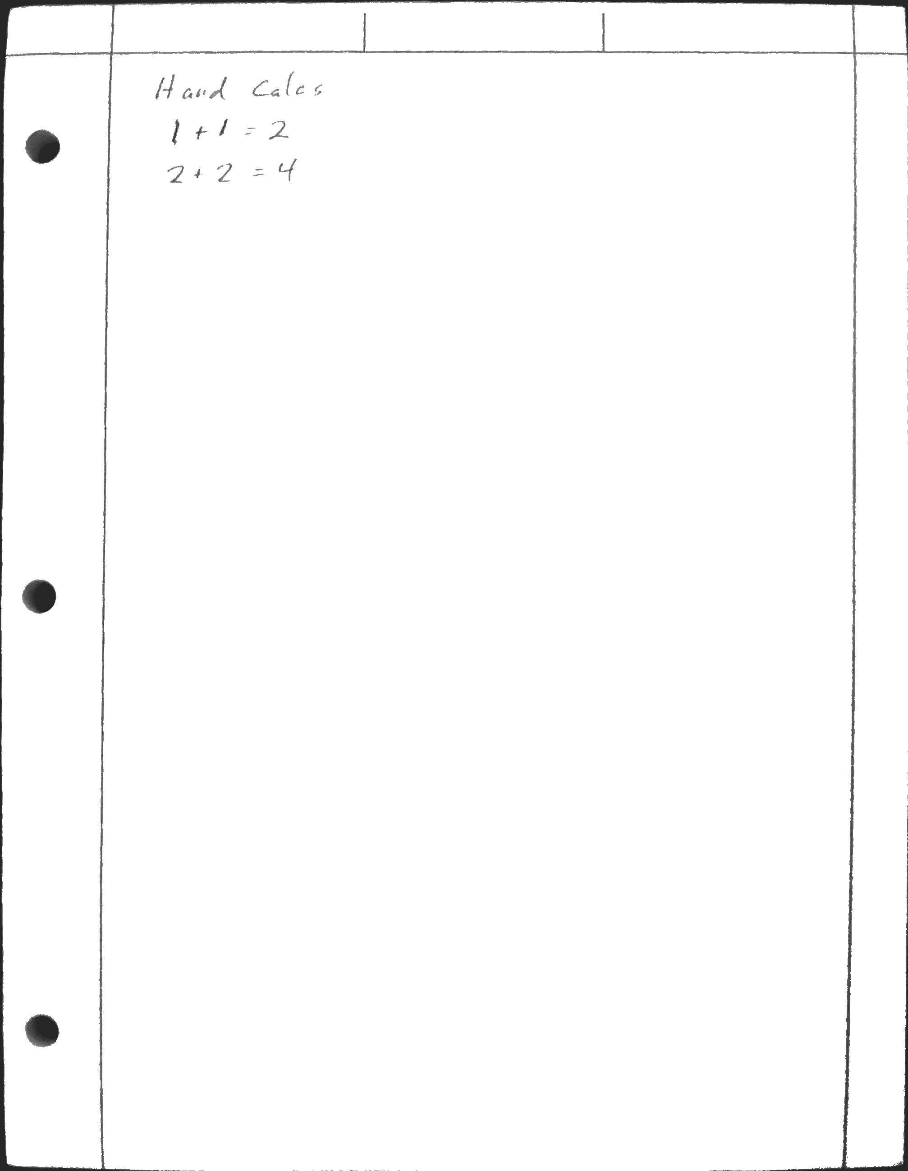

Additional Test Cases

All “if” checks were tested true and false and all lines of the code were tested.